Luis Medina

ID: 012020203

Data Management – D597

Task 2: Non-relational Database Design and Implementation

Part 1: Design Document

A1. Business Problem

The cosmetics industry is facing a challenging problem right now with customers with varying skin types, concerns, and budgets, making it difficult to provide personal product recommendations. In addition to many products available to customers, it’s easy for them to feel overwhelmed and often buy products that are not for their needs. This will lead to the customers being dissatisfied with their purchases and will cause a return and reduce customer loyalty. Developing a personal database for business that can help customers with products based on criteria can lead to great customer satisfaction.

A2. Database Justification

A NoSQL is the ideal solution for the business problem from the previous section and here are several reasons why. Since the data that will be included will vary between different ingredient lists and skin-type compatibility flags, we need a database to store the documents that is flexible with data types. By looking at the JSON files I can see that the data has nested fields, so the perfect way to go about this is with a document-based model like MongoBD. Lastly, using a NoSQL database will be scalable, so we will be able to filter our search products easily without performance degradation.

A3. Database Type

The best type of NoSQL database to use for this type of data provided is going to be a document-oriented database, such as MongoDB. Using this would easily store data in JSON format, making it perfect for the data we have. MongoDB would easily be able to handle nested fields like ingredients or skin-type compatibility, making it another reason to use this type of database.

A4. Data Usage

Here I am going to describe how the business will make use of the data. First, it will be with personalized recommendations, meaning that when a user selects their skins type, the database can query and return the products that best suit their skin type. Another usage with the data is that they will have an easy way to filter data, that way customers can search or filter by brand, price range, product rank, or ingredients. Then, it can be used for analytics for business to better understand trends in customers. By understanding trends in customers, it will help with inventory systems as they won’t have to worry about running out of popular products because they will know what to order.

B. Scalability

Next, for scalability, which will be a critical part of the database, as it grows there will be more demand, and we would not want any problems to come up. With more customers, more product data, and more queries, we want to be able to handle all this, so it doesn’t slow anything down. First, its horizontal scaling, MongoDB supports partitioning data across multiple servers. This is helpful because as more product is added into the database, then it will grow horizontally instead of vertically. Next, I will use indexing on fields that are frequently used in search queries. This will reduce the query latency, and this will be important when the database increases in records, as the company will get new customers and new products. This will also help in the future if the company requires any data analysis done on the data. Another useful quality of MongoDB is that it allows the document to have different set of attributes. Meaning that if we need to add new products or categories, we can do so without redesigning the entire schema.

C. Privacy and Security

Here we have one of the most important parts when designing and implementing a schema. It is super important to protect customer and product data, therefore there are going to be some measures that must be followed. First, not everyone has access to the database, I will use authorized users to give certain people certain access to the database. For example, an admin would have the most access compared to an analyst who would have access to pull data. This way only authorized people will be able to access the sensitive data. Next, I will use encryption to protect the data from being intercepted or leaked while in storage or transmission. Lastly, I will create a schedule for regular backups of the database to make sure nothing gets lost. There will be tested to check the back up data is up and correct, to minimize the risk of losing data in case of a hardware failure or accidental deletions.

D1. Database Instance

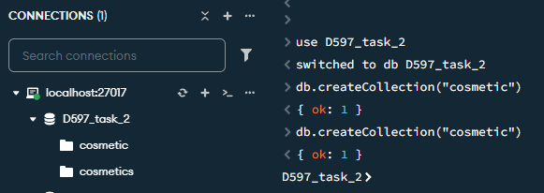

Now that we have created the database and the collection, it’s time to insert the data.

D2. Insert Records

Here I am going to insert the JSON file into the document we created earlier. Here, I am using “mongoimport” to import the JSON file into the database.

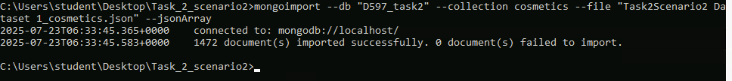

Now I am going to check if all the data was imported correctly in the database.

So, we can see that the data was successfully imported and now we can move on to the next section of the assignment.

D3. Queries

Now for this part I am going to provide the scripts for 3 queries to look for specific information that will be helpful for the business problem. For the first query, I am going to find products for sensitive skin, and this will return a list of products that are compatible with sensitive skin.

Here are the results for the first query, the screenshot only shows a few of the results as the screenshot would be too large if I include all of it. Now for the second query that I will create to answer another question, for this I want the top-rated products under $75.

Once again, I will only provide a screenshot snippet of some of the results as the screenshot would be too large if I included everything. Lastly, for query number 3, I will recommend a product for oily skin, sorted by rank. I will provide the script and the results in the screenshot below.

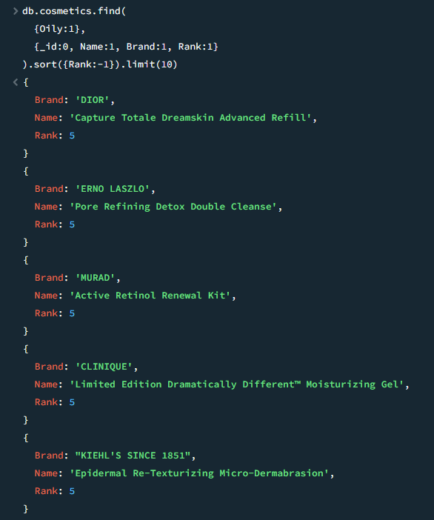

Here is the final screenshot of the 3 queries that were used to help with the business problem. Now for the next part I will focus on how to optimize the queries.

D4. Optimization

Now, we are going to improve the queries that I wrote in the above section by applying optimization techniques, which are going to be indexing. I will compare the results from before and after by using the .explain(“executionStats”). First, I will apply the indexing to the first query and compare the results before and after running it.

After

Looking at the results, we can see that the results after applying the indexing made it faster, meaning that the optimization technique I used worked out.

Now, to look at the second query from the section above, this first screenshot will show the results before optimization technique and the second screenshot would be the results after running the optimization technique.

Looking at the results, we can see that the techniques in fact did improve the results from the query. Just looking at the total Docs Examined, you can see that I reduced by over half, meaning MongoDB did not have to look through every single document.

Now to finally look at the last query to check if there have been any improvements made from the techniques I used.

Just like the second query, we can see that there was a great improvement made after applying the indexing techniques to the query. For example, if we look at the total Docs and Keys Examined, we can see the big difference after applying the techniques to the query results. Then, we can clearly see that both results returned the same amount, which is 10.

F. Sources

For the sources I used the Learning MongoDB from Linkedin Learning that was provided by the class materials and the documentation from MongoDB.

MongoDB, Inc. mongoimport – MongoDB Database Tools. MongoDB

Documentation. Retrieved July 24, 2025, from <https://www.mongodb.com/docs/databasetools/mongoimport/>

Horn, A. (2022). Learning MongoDB. Linkedin Learning.

https://www.linkedin.com/learning/learning-mongodb-17360744/modern-database-and-application-design-with-mongodb.